**User Manual of IST Austria Emergency Ventilator**

V0.1

Last updated:

24.04.2020

Electronic Workshop

Institute of Science and Technology Austria

T +43-(0)2243 9000-1055

Am Campus 1

A-3400 Klosterneuburg

Written by:

Abdulhamid Baghdadi ([abdulhamid.baghdadi@ist.ac.at](mailto:abdulhamid.baghdadi@ist.ac.at))

Daniel Waldhäusl ([daniel.waldhAeusl@ist.ac.at](mailto:daniel.waldhAeusl@ist.ac.at))

Table of Contents

1. Description 3

2. Controller Box 4

3. Operation 6

4. Alarms 7

5. Safety Measures 8

# Description

This respirator is based upon the idea of pressing an ambu bag, which can be removed and operated manually in case the respirator fails. There are two operation modes: controlled-volume and controlled-pressure respiration. The first mode provides a controlled volume of air to the patient in a set amount of time, while the second maintains a set airway pressure for a given inspiratory time. For more details about the operation modes, please refer to the firmware documentation.

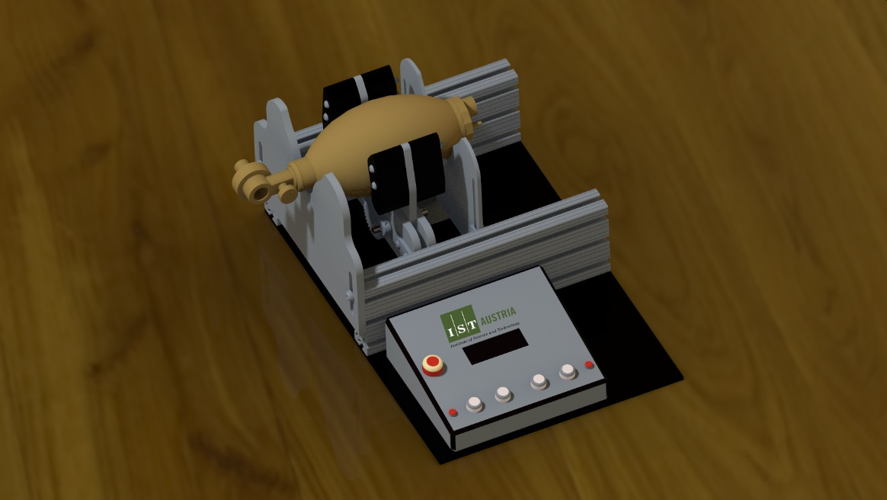

Figure - IST Austria Emergency Ventilator

The following parameters are adjustable:

|  |  |  |
| --- | --- | --- |
| **Parameter** | **Range** | **Unit** |
| Volume* | 300 - 900 | mL |
| Breath rate | 8 – 40 | Breaths per minute |
| Inspiratory : Expiratory ratio | 1:1 – 1:4 |  |
| Threshold pressure** | 10 - 30 | mBar |

Table 1 – Control Parameters

*\*applies only to the controlled-volume mode*

*\*\*applies only to the controlled-pressure mode*

# Controller Box

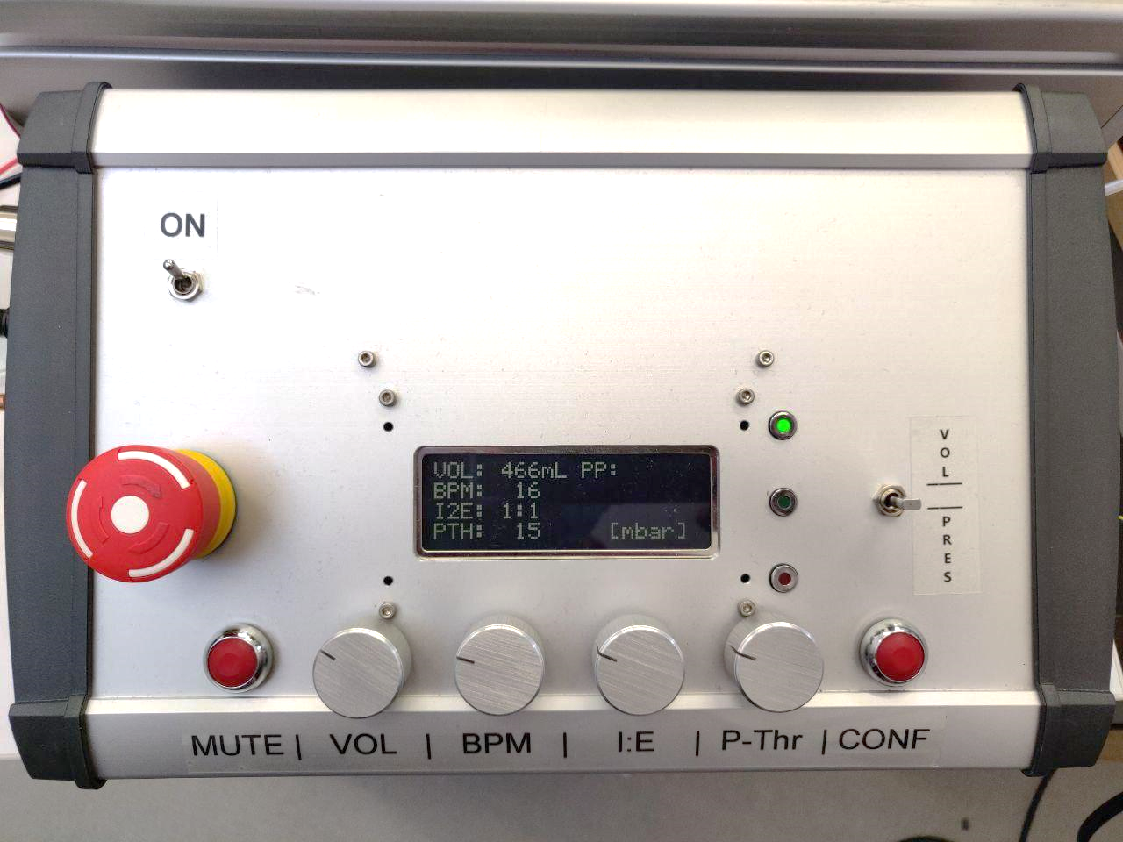

9

10

11

13

12

7

6

5

4

8

3

2

1

1. Power switch.
2. Emergency button.
3. Mute button: shuts the alarm off for 3 seconds.
4. VOL control knob: sets the value of the breath volume in mL.
5. BPM control knob: sets the breath-per-minute rate.
6. I:E control knob: sets the inhale-to-exhale rate.
7. P-Thr control Knob: sets the pressure threshold value. This value only affects the operation in pressure-control mode.
8. CONF button: confirms the recent change of parameters. If this button is not pressed after changes, parameter changes have no effect and the screen will start blinking until this button is pressed.
9. Alarm indicator: Lights red when an error occurs. Description of the error will appear of the screen (see chapter 4. Alarms).
10. Operation indicator: lights green when the respirator is running (not in idle mode).
11. Power indicator: lights green when the power supply is connected.
12. Mode switch: switches the respirator between volume control, pressure control or idle mode.
13. PP OR volume: depending on the operation mode, this indicator might read PP (Peak Pressure) or Volume. In volume-control mode, “PP” shows the maximum pressure that was reached in the last cycle, which means, that this value will be updated by the end of each cycle. In pressure-controlled mode, “Volume” shows the volume inhaled in the last cycle.

# Operation

1. Plug in the 24V power supply cable.
2. Make sure the air pipe socket on the side of the controller box is connected through a rigid air tube to the designated place for measuring air pressure in the ventilation system.
3. Make sure the mode switch is standing on the idle mode; otherwise, the ventilator will start working as soon as the power is switched on.
4. Switch the power on. If the controller does not power up, make sure the emergency button is not pressed.
5. Adjust the needed parameters using the control knobs, then click confirm when ready.
6. Move the mode switch to the desired mode.
7. In case an alarm goes up, start ventilating the patient manually and check chapter 4. Alarms to see the cause for the alarm

# Alarms

The following errors will cause the alarm to go off and will be visible on the screen until the error cause is eliminated. To stop the buzzer, please click on the MUTE button.

|  |  |
| --- | --- |
| **Alarm** | **Reason** |
| LOW VOLUME | The minute-volume in pressure mode fell below the hardcoded minute-volume minimum. |
| MOTOR ERR | The motor is either unplugged or blocked. Alarm occurs if the current exceeds the hardcoded maximum motor current or the motor was not able to move for 2 seconds. |
| PRES ERR | The pressure is either too high or too low. High pressure would indicate a bad compliance of the lung, low pressure would indicate leakage. |

Table 2 - Alarms

# Safety Measures

1. Keep the ambu-bag easily removable for manual respiration in case of emergency
2. If alarm goes up, use the bag manually and call for help to fix the cause for the alarm
3. Make sure every individual around the respirator is familiar with its operation principles or at least the sound of the alarm.